**ASSIGNMENT NO 2**

**SUBMITTED BY:**

**RABEEA FATIMA  
REGISTRATION NO: 2023-BSE-049**

**SECTION: B  
SUBJECT: CLOUD COMPUTING**

# LAB# 02

**TASK: Download Git.**

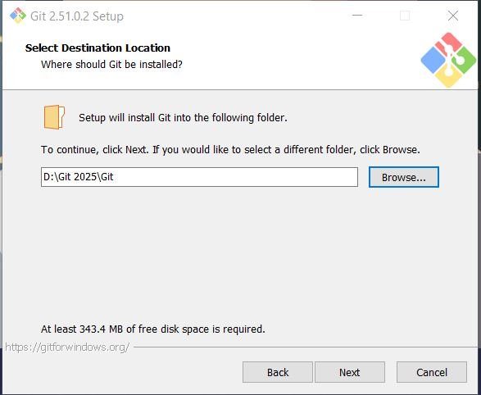

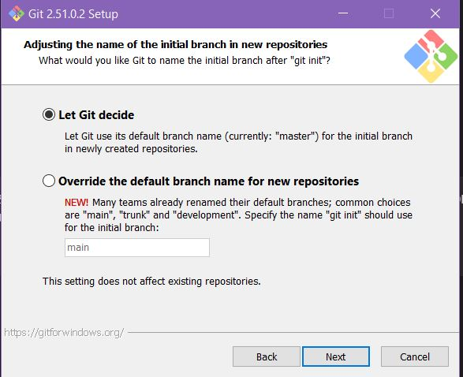

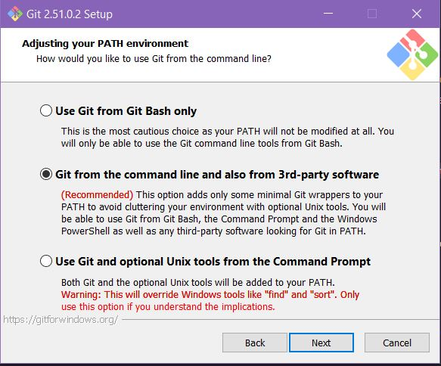

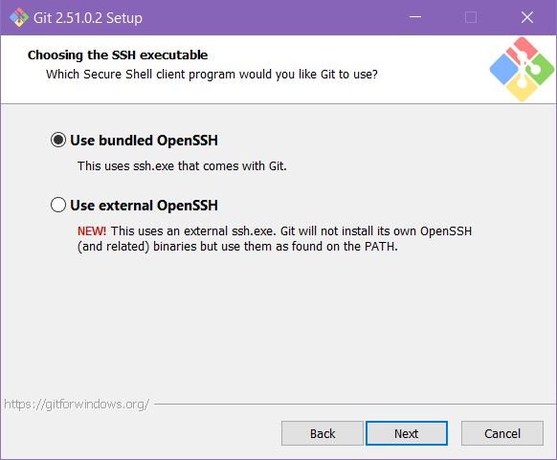

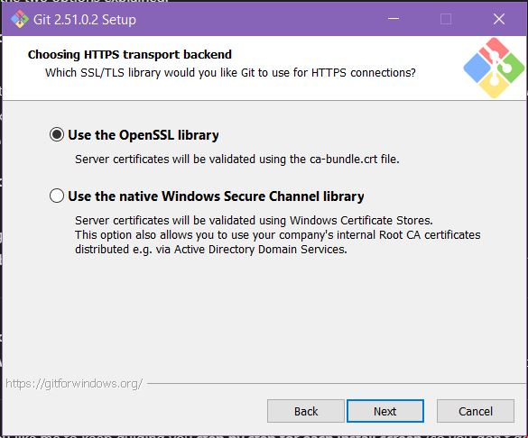

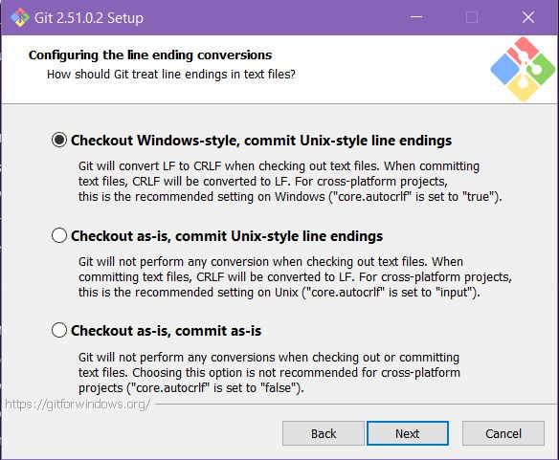

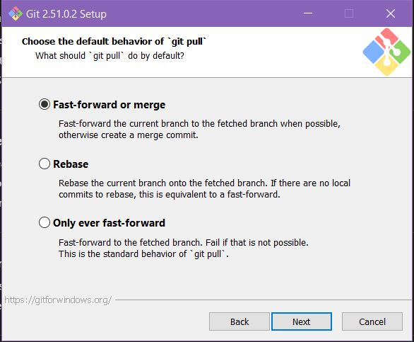

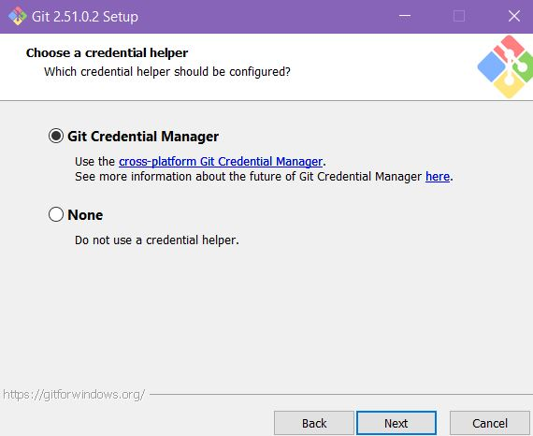

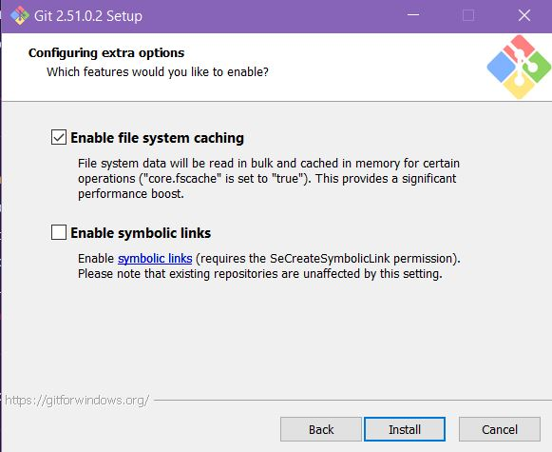

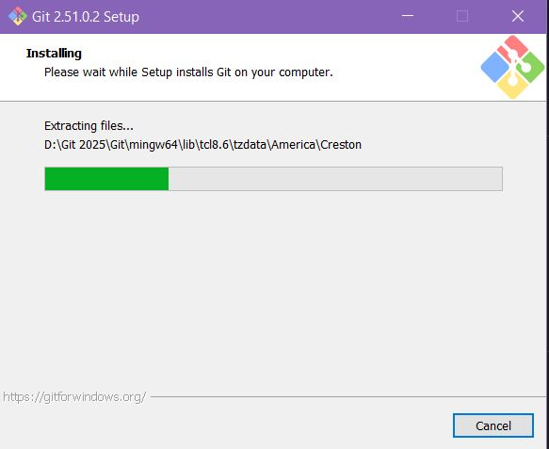

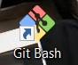

**TASK 1: Create a private GitHub repository.**

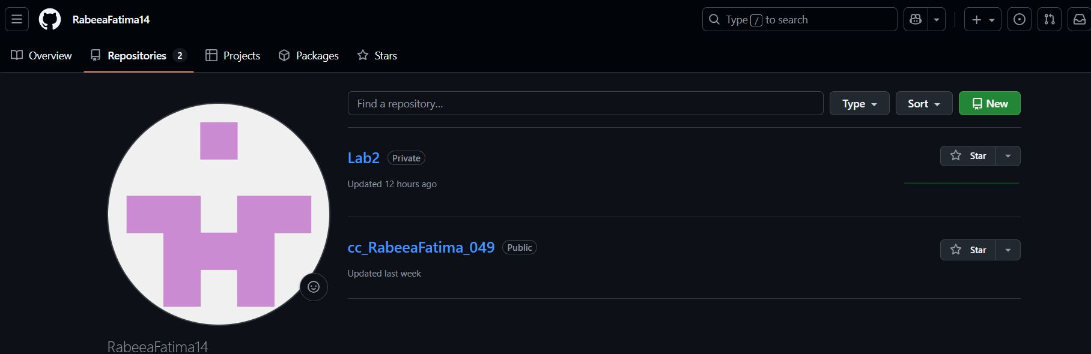

**TASK 2: Connect repository.**

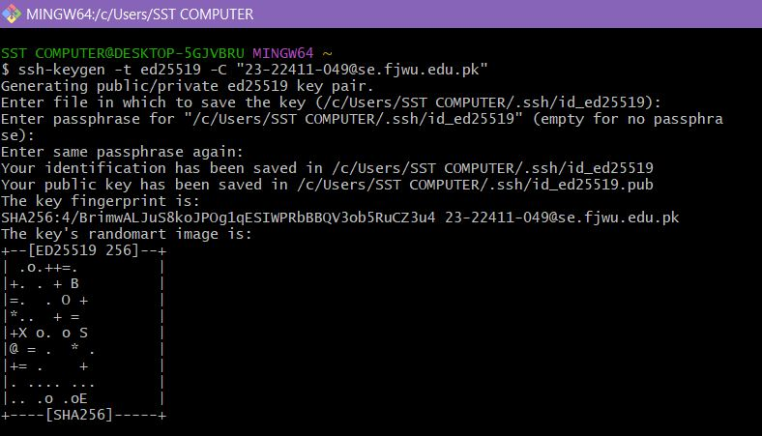

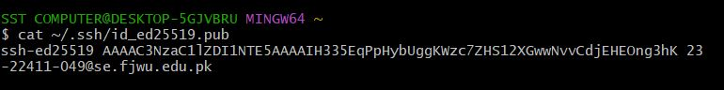

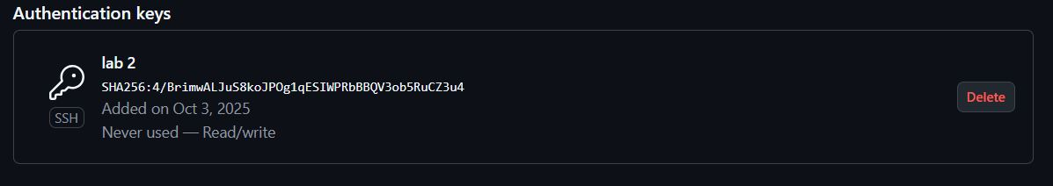

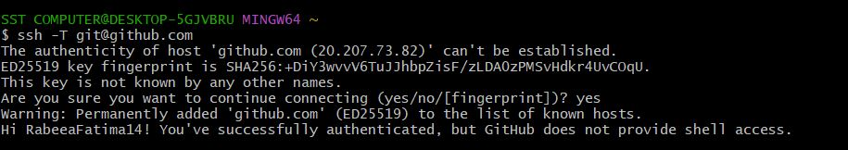

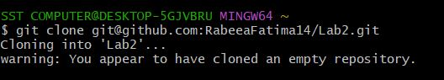

**TASK 3: Configure Git username and email.**

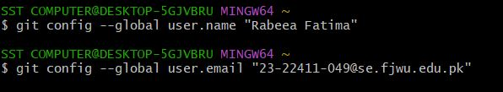

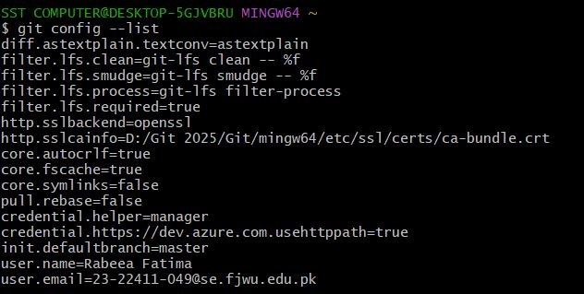

**TASK 4: Explore the .git folder.**

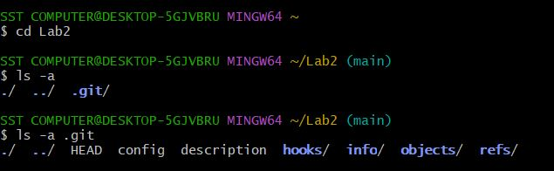

**TASK 5: Local repository management.**

**D:\Books and notes sem 5\Cloud Computing\Task5 A.JPG**

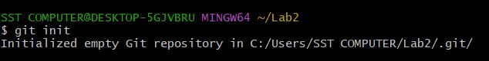

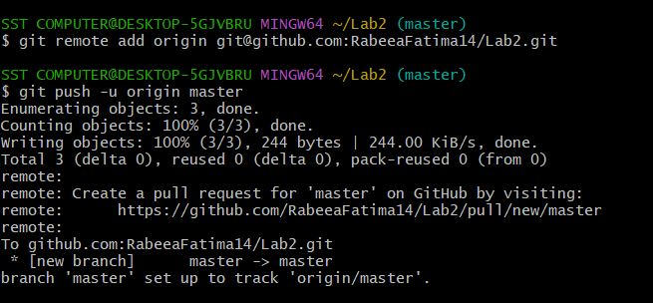

**TASK 6: File status & staging.**

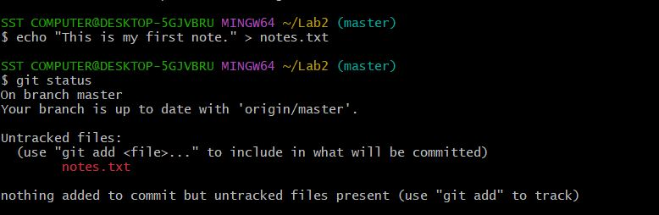



**TASK 7: Branch creation using GitHub GUI.**

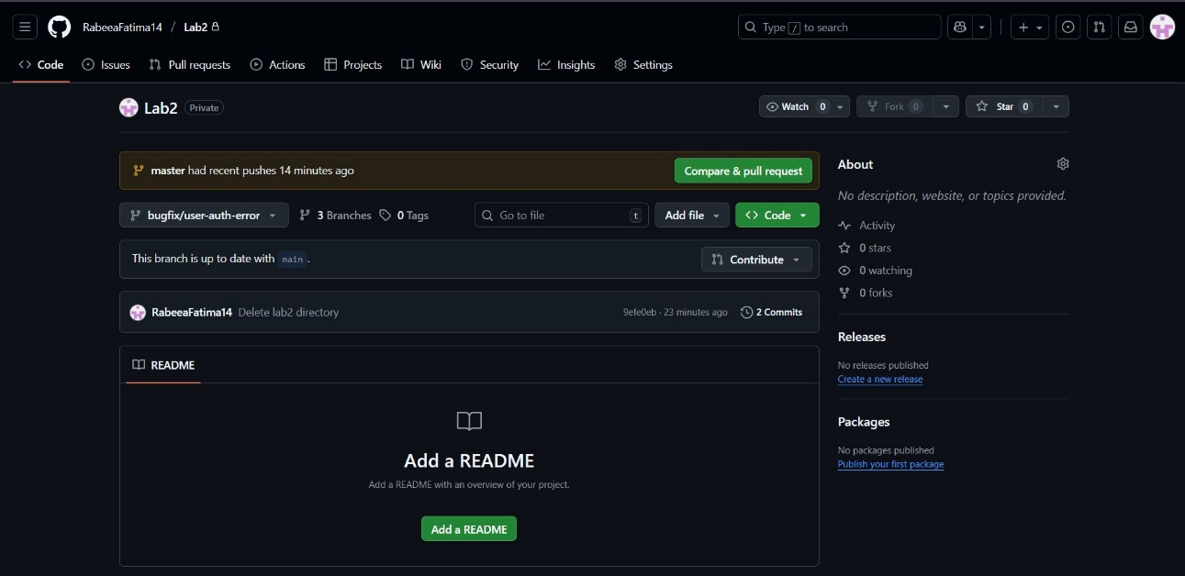

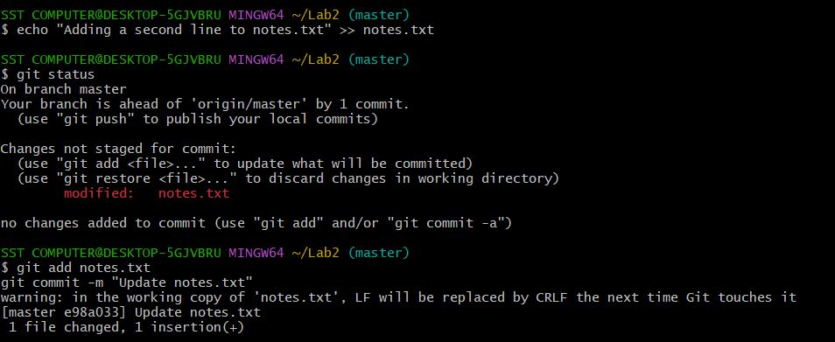

**TASK 8: Branch creation & push using GitBash.**

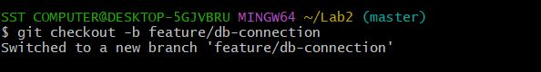

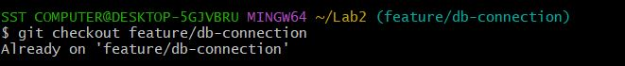

**TASK 9: Branching & Merging.**

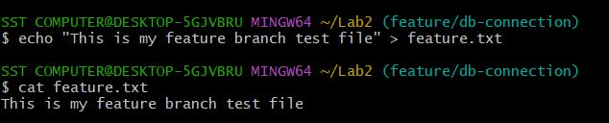

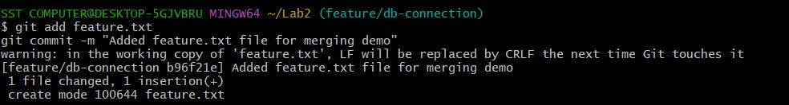

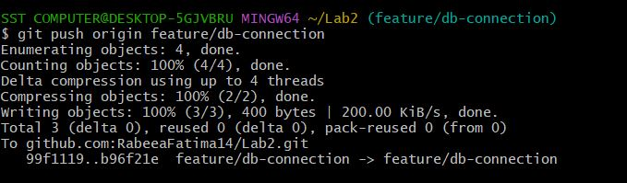

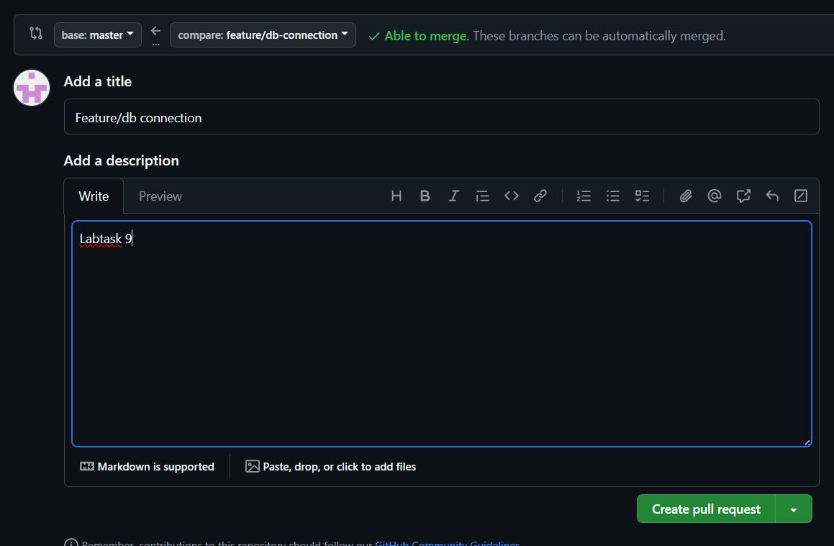

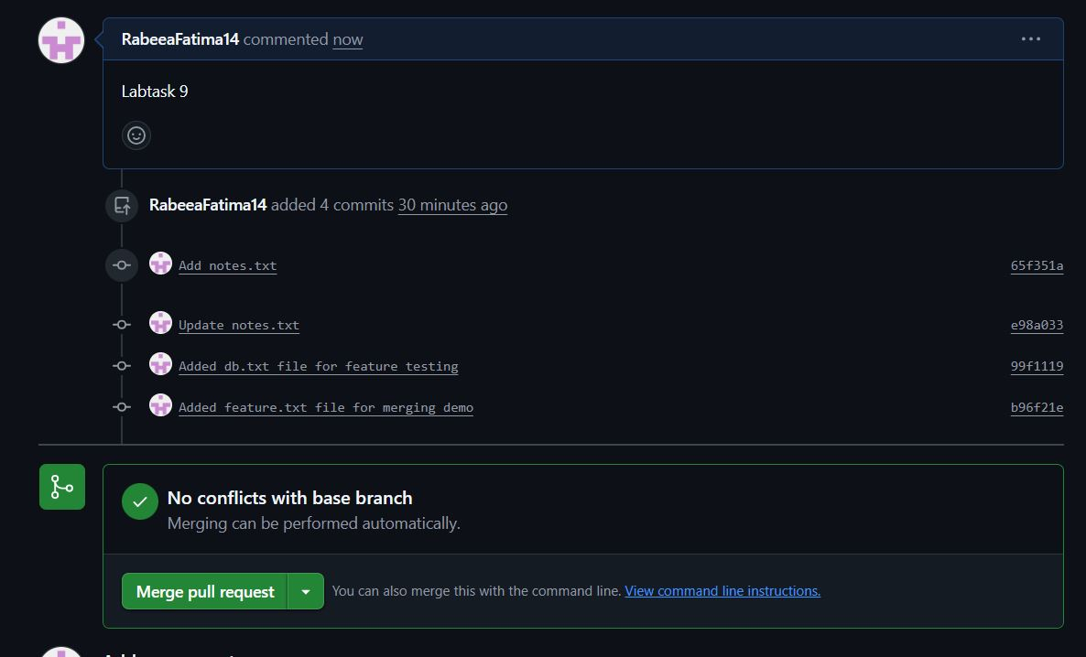

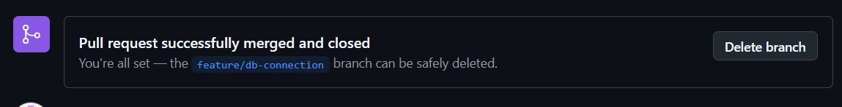

**TASK 10: Pull request and branch review.**

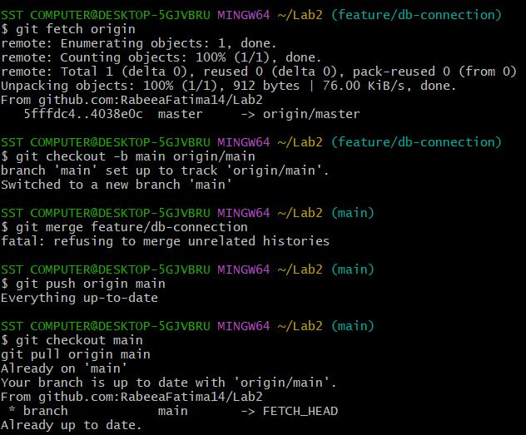

**TASK 11: Detailed branch strategy (Develop/Staging).**

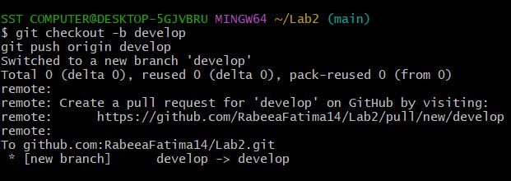

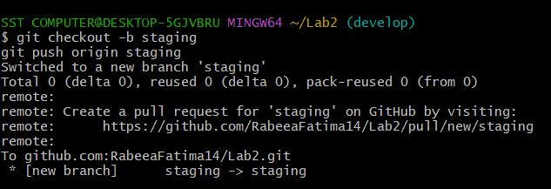



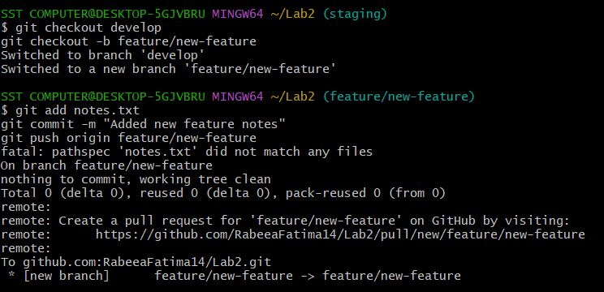

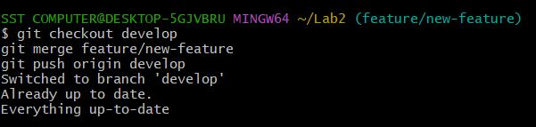

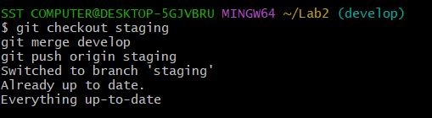

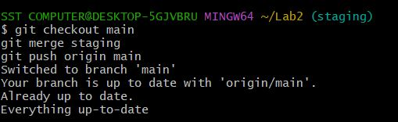

**TASK 12: Code review workflow.**

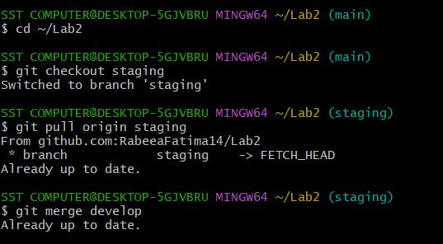

**BONUS TASK: Simulated team collaboration.**

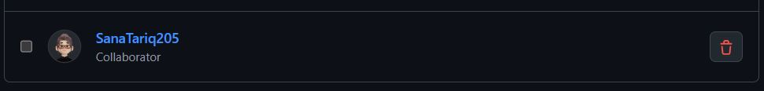

**EXAM EVALUATION QUESTIONS**

**QUESTION 1: Advanced branching & merge verifications.**

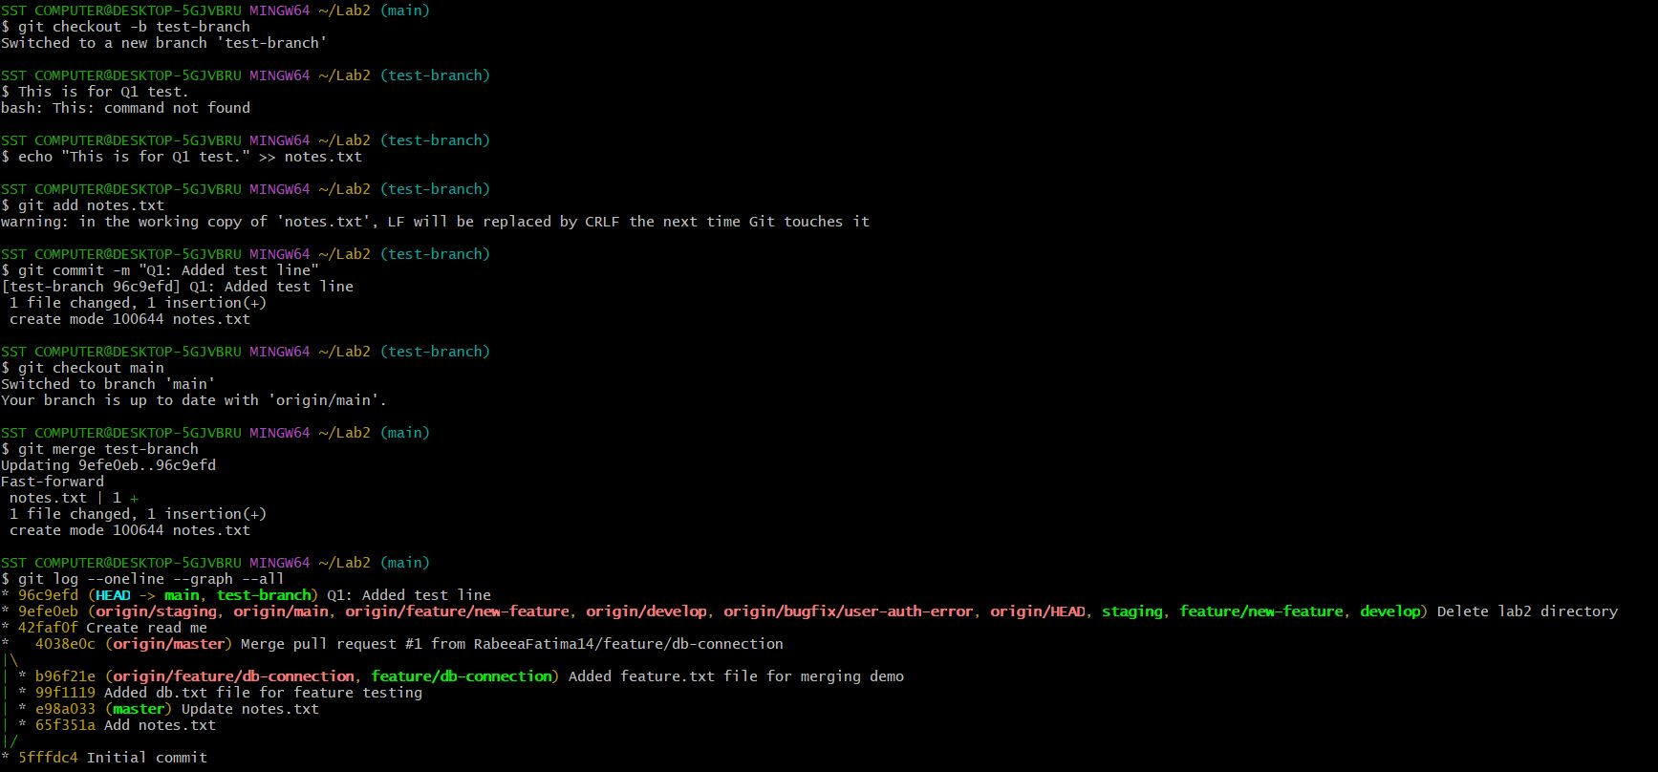

**QUESTION 2: Multi-Stage Workflow Stimulation.**

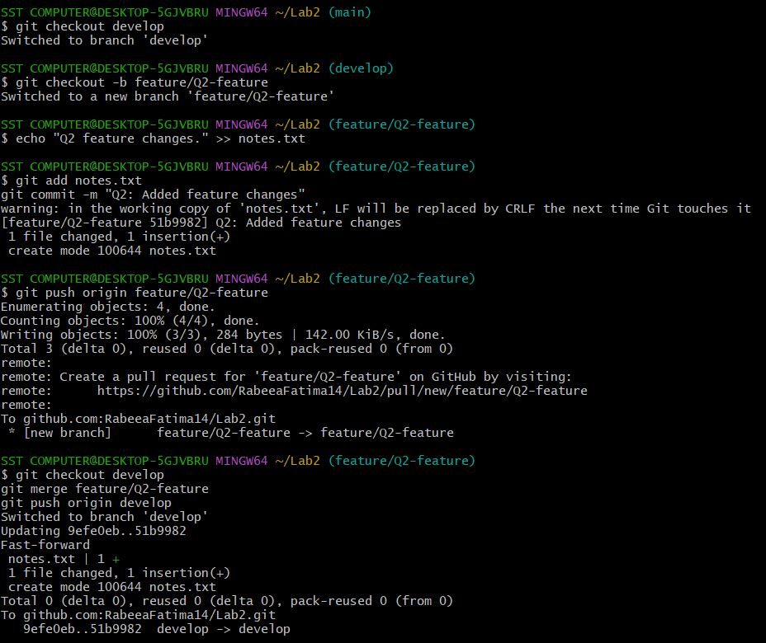

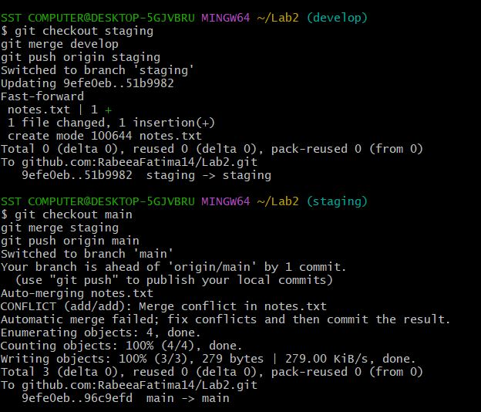

**QUESTION 3: Collaboration and conflict resolution.**

